Appendix i - Safety Procedures and User Information.
This document contains useful tips and the safety procedures at Sparkwell Parish Hall, which all hirers MUST follow and forms part of the Hiring Agreement and is in addition to the Standard Conditions of Hire.
In the event of an emergency there is a list of Trustees contact details on the front door and in the User and Fire Manuals
Opening and Closing the Hall
On return of the completed, signed hiring agreement you will be issued an invoice and door entry code, which you will receive via email. Please make a note of this number and be aware that the code will only work at the time of your booking, i.e. if you have booked the hall from 1pm, the code will only work at 1pm and not earlier. It will expire at the end of your booking. Regular users of the hall will be issued individual codes.
Please ensure that any outside caterers, contractors and bar staff are aware of the hire period and that they will not be able to enter before or leave after the hire period unless separate arrangements are made in advance with the Bookings Secretary.
For evening parties guests are expected to vacate the premises within fifteen minutes of the end of the licensed period. 23:45 hours (unless the event is New Year’s Eve), only those helping to clear up the Parish Hall should then be on the premises. Failure to comply with this will result in forfeiture of your deposit.
Entry Checks
When first opening the Hall, Hirers must carry out the following checks:
- Check the location of all Fire Exits, Fire Panel (Main Foyer), Call Points (Break glass), Fire Extinguishers and the Assembly Point at the entrance to the woods (by the tree stump). The Fire Folder is in the Main Foyer next to the fire panel. Fire plan on the wall.

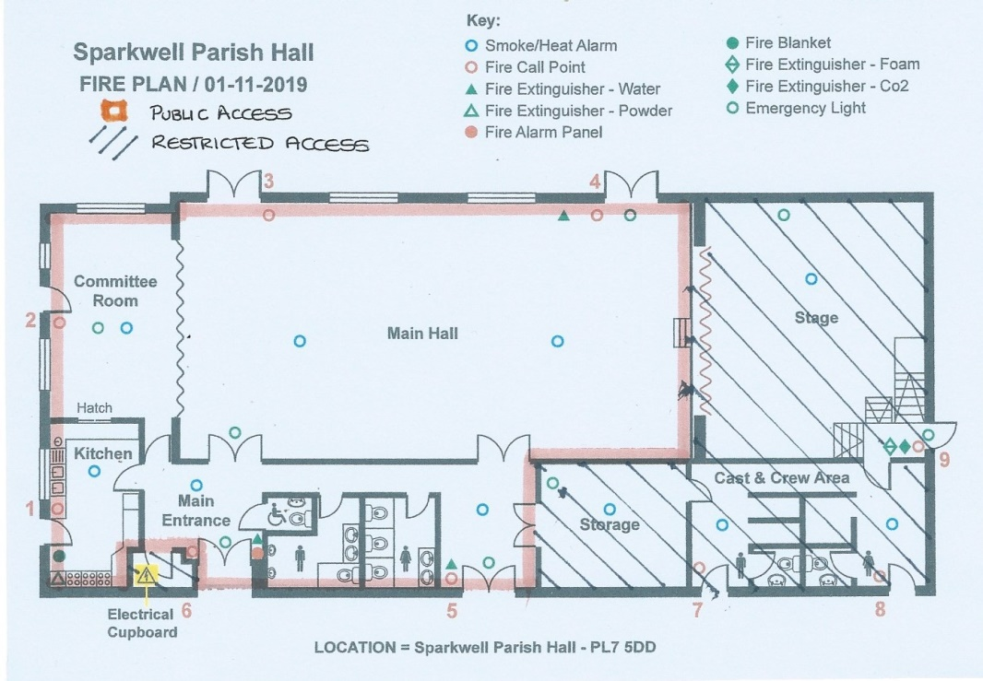

- Check that all exits and walkways are free from any obstructions and ensure this remains so during the period of hire.
- Check that all doors open freely and that you can unlock the committee room and kitchen doors if required.
- Check you know the location of the first aid boxes (Main Foyer and Kitchen)
- There is no telephone line at Sparkwell Parish Hall (SPH) check someone in your party has a charged mobile phone with signal (There is a pay phone by the carpark main entrance)
- Check “The Hall User Manual” in the Main Foyer, which contains useful information.
In the event of a fire
- If the fire alarm goes off, evacuate the building and assemble at the entrance to the woods (tree stump). Call the Fire Service 999 or 112 and a Trustee
- If you suspect a fire (however small) activate the alarm at the nearest call point, evacuate the building and assemble at the entrance to the woods (tree stump). Call the Fire Service 999 or 112
- The person booking the hall is responsible for knowing who is in the building, doing a head count, and must greet the fire service to advise them.
- Fire extinguishers are located to enable safe egress, only use if trained to do so.
In the event of any other emergency
- Call the appropriate Emergency Service, 999 or 112 and a Trustee
- Any medical emergencies or injuries must be recorded in the accident book (in the main foyer) and also reported via email to bookings@sparkwellparishhall.co.uk.
Your location is:
Sparkwell Parish Hall. Sparkwell. PL7 5DD
General Requirements
- Ensure you have adequate first aid cover for your event, if required by legislation.
- Candles and naked flames are not permitted in the building.
- Do not bring onto the premises any portable electrical appliances which are not in good order and do not leave operating while unattended. Commercial hirers will need to ensure all portable appliances have a current PAT label attached. Ensure all leads are stowed safely and electrical sockets are not overloaded.
- Do not operate or touch any electrical equipment where there are signs of damage, exposure of components, water penetration, signs of scorching, damaged cables, etc.
- Avoid using extension leads were possible, daisy chaining is prohibited.
- Ensure trip hazards are avoided.
- Do not work on steps, ladders or at height unless trained to do so. Ensure ladders are properly secured, and another person is present. Access to the roof store is only permitted in the presence of a Trustee.
- Use the trolleys and chair movers to transport tables and chairs respectively
- Two persons to each table for setting up and putting away for safe handling and to avoid damage to the tables.
- Chairs to be stacked maximum of 2 high.
- No children allowed in the kitchen unless closely supervised for certain tasks, such as scouts completing cooking tasks, etc.
- Heating - The hall has been fitted with radiant heaters. The controls are located next to each heater. There is a timer switch and a full/half heat switch for each heater. The heaters are instant and a warm up period is not necessary. There is no advantage in putting heaters on in areas of the hall that are not being occupied as they do not heat the air just the person. These must be turned off when vacating the hall
- Clean up any spillages immediately and when mopping floors after events avoid excessive wetting and make all those present aware of wet floors.
- The hall has outside lights please ensure these are turned on (switch by front door) when required to avoid tripping in poorly lit areas.
- Things to bring - Tea towels, waste sacks, charged mobile phone.
- Decorating the Hall - If decoration is required e.g. balloons, banners, etc. only fix to areas where damage won’t occur, such as glass, using unmarking tape or white tack and remove after use. Only biodegradable wedding or table confetti is allowed.
- Car parking - The Parish Hall car park will accommodate a good number of cars if they are parked sensibly. The tarmac area in front of the hall has disabled spaces. Be aware that the car park is also used by the school and local dog walkers so please drive with care. The car park surface is uneven in places. Put the outside lights on if needed.
- Records - A book has been provided in the main foyer to record any damage, breakages, faults, comments or complaints or if urgent attention is required email:bookings@sparkwellparishhall.co.uk
- Smoking- The Parish Hall has a No Smoking/Vaping Policy.
Please do not dispose of cigarette butts in the planters or outside the front door.
If smoking outside the building please do so away from the front entrance.
- The Parish Hall has WiFi. Password is Sparkwell1
- Safeguarding - All hall users have a duty to safeguard children, young people and vulnerable adults. A copy of our policy is available in the User Manual.
- The Stage - Access onto the stage is not allowed unless specifically booked and instructions given.
- Dishwasher - Instructions are on the wall. Mains switch is under the work top next to the general waste bin. Please switch on for about 30 mins before using it, to avoid soap bubbles flooding the kitchen. Detergent and rise aid automatic.
The dishwasher needs to be emptied, pumped out and the drain needs to be removed and cleaned at the end of each session.
- Range Oven - Instructions are on the wall. Clock needs setting before ovens work. (please note it’s the two black buttons on the end on the left to set the clock)
- Water Heater - Mains switch under the work top beside the general bin. Refills automatically. Electric kettles also available
- Sound System - Mains plug, power on. It will play CDs. There is a jack plug for connecting mobiles and tablets. An adaptor is available for those devices that do not have a headphone socket (e.g. i phones). Please leave the adaptor connected at the end of your session. The Master volume is on the far right. Individual controls labelled.
- Waste Management - Please take your general and recycling waste home with you.
All food waste must be removed and taken home. No food should be left in the fridges or freezers.
There are bins for sanitary waste in the toilets.
A nappy bin is provided in the baby change toilet (For NAPPIES ONLY).
- Cleaning – The cleaning cupboard is in the second lobby containing Henry, brushes, dustpan and brushes. Mops and buckets are colour coded (yellow-kitchen, red-toilets, green-all general areas) Floor cleaning detergent and multi surface cleaner are in the kitchen window sill.
The hall MUST be left clean for the next user which maybe immediately after your booking. Wipe down tables, chairs, hard surfaces, door handles, etc. if used. Leave the kitchen clean and tidy. Wipe down oven if used. Check the toilets are clean and tidy. Brush and hoover the floors. Mop if necessary.
- Bouncy Castles
The Parish Hall has an approved list of suppliers available from the Bookings Secretary
(Information from our insurers which must be complied with)

- access and use is controlled by an authorised adult (this can be a parent attending the party) employee/volunteer at all times
- when used outside a building, it is securely anchored to the ground at each anchor point
- each anchor point is signed, or otherwise marked to be made easily visible, and wrapped to prevent injury
- soft matting is used to cover hard surfaces adjacent to the front or any open sides where there is a risk of injury from falling from the inflatable
In addition, using bouncy castles can increase the risk of injury, particularly to children and others who may not be aware of the dangers.
Insurers offer the following risk management advice for overseeing bouncy castles:
- We expect you to take extra care to prevent injuries by making sure measures are put in place that help reduce this risk and our guidelines are:
- to follow the manufacturer’s or supplier’s safety recommendations
- requiring children to remove sharp articles like shoes, buckles or jewellery
- not allowing overcrowding, particularly by children (to help prevent knocking into each other)
- not allowing a mix of large and small children at the same time (to avoid larger children crushing the smaller ones)
- not allowing use by adults and children at the same time
- not allowing any access to the very youngest children, e.g. under 2 years old
- soft matting is used to cover hard surfaces adjacent to the front or any open sides where there is a risk of injury from falling from the inflatable.
Material damage is the responsibility of the owner.

Exit Checks

At the end of your hire session please use the Exit Checklist (Appendix ii) to ensure the hall is left safe, secure, everything is clean and put away ready for the next hirer.

Sparkwell Hall is run entirely by volunteers and your cooperation and compliance with the hiring terms and conditions is appreciated. Should we receive complaints following your booking with, for example the cleanliness of the hall, or the heaters/lights etc. left on, we reserve the right to charge accordingly and to refuse further bookings in the future.
We hoped you enjoyed the Hall and please take all your belongings with you.

